Day 60 | Part – 1: Integration Overview by Sanjay Gupta & Ankit Jain:

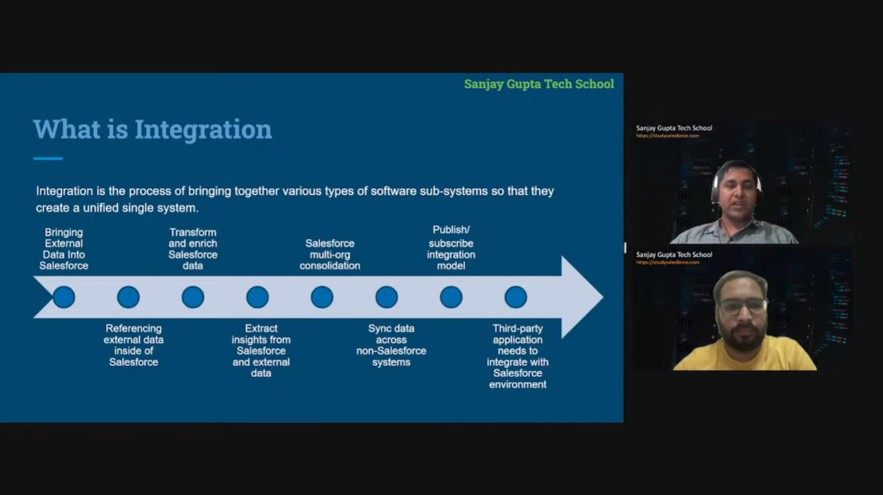

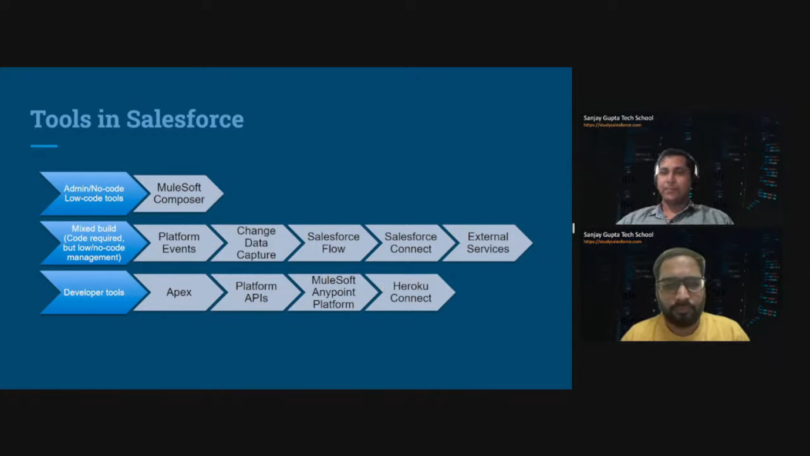

* Mulesoft composer is third part application used for integration.
* We can use different type of sources to do integration and Salesforce provides multiple way to do the integration.

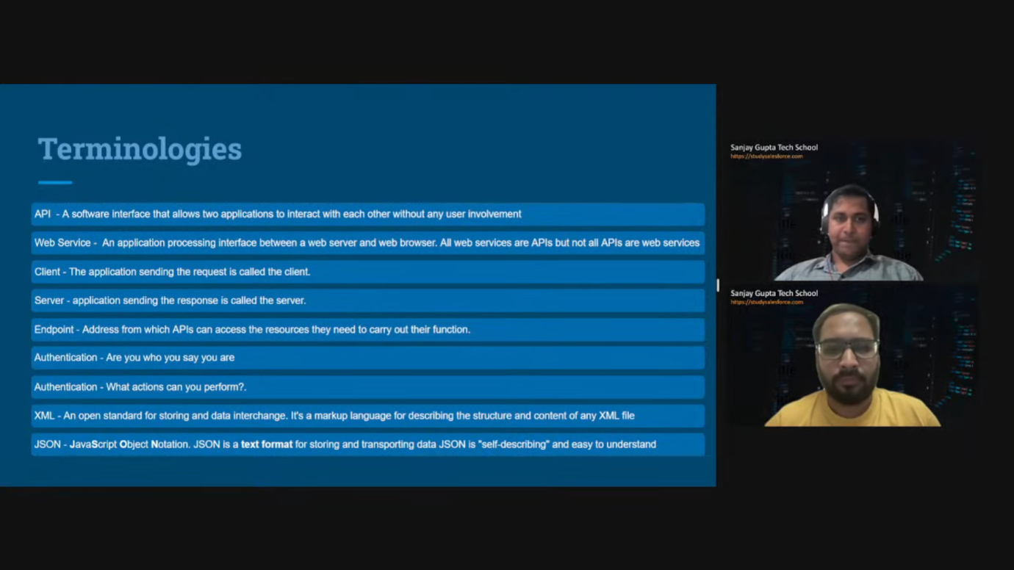

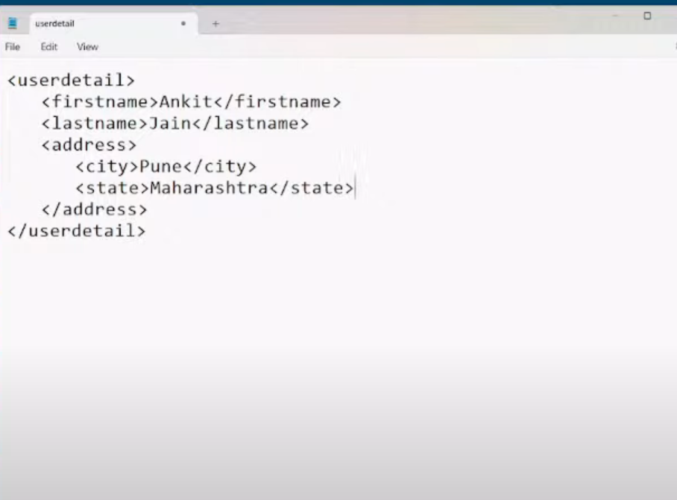

* Above pic, it is an example of XML file format for carrying data.

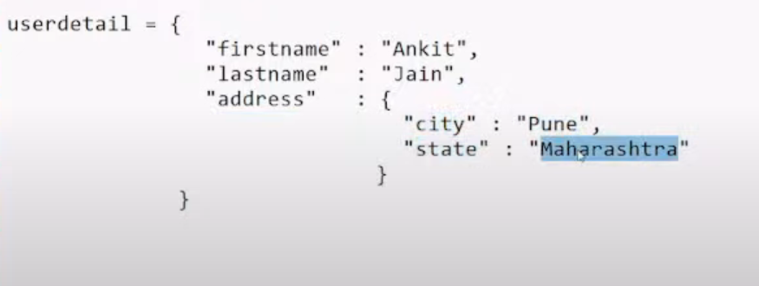

* Above pic is showing format of JSON data.

Note: when you need more secured system integration then go for SOAP API like financial system integration or banking system API integration.

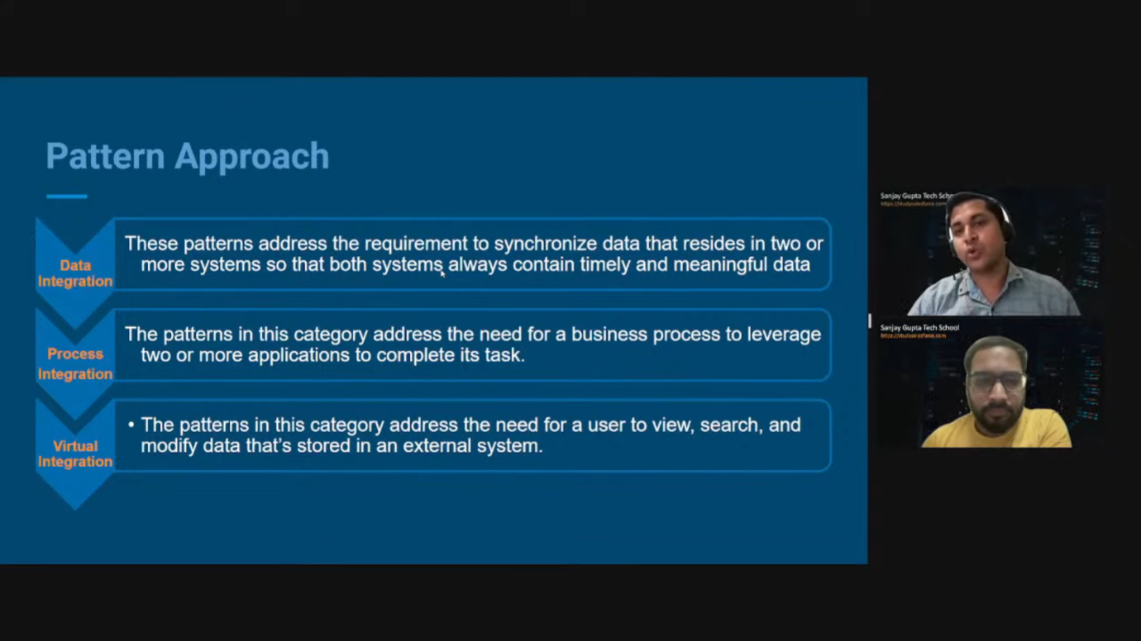

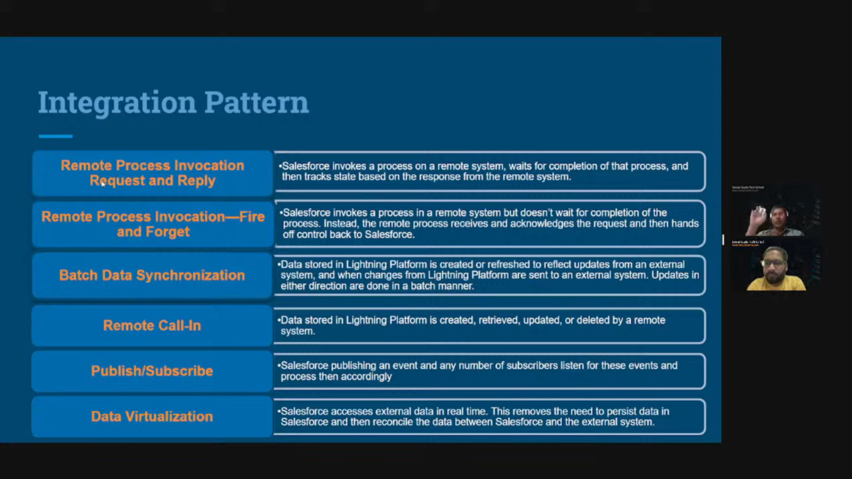

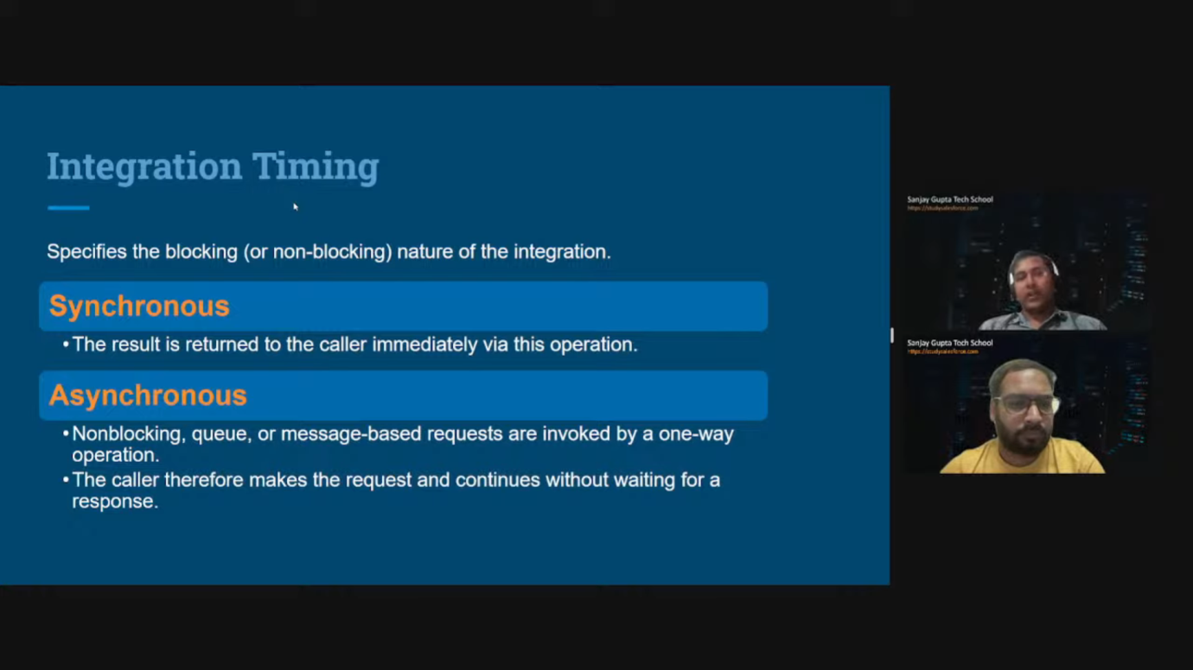

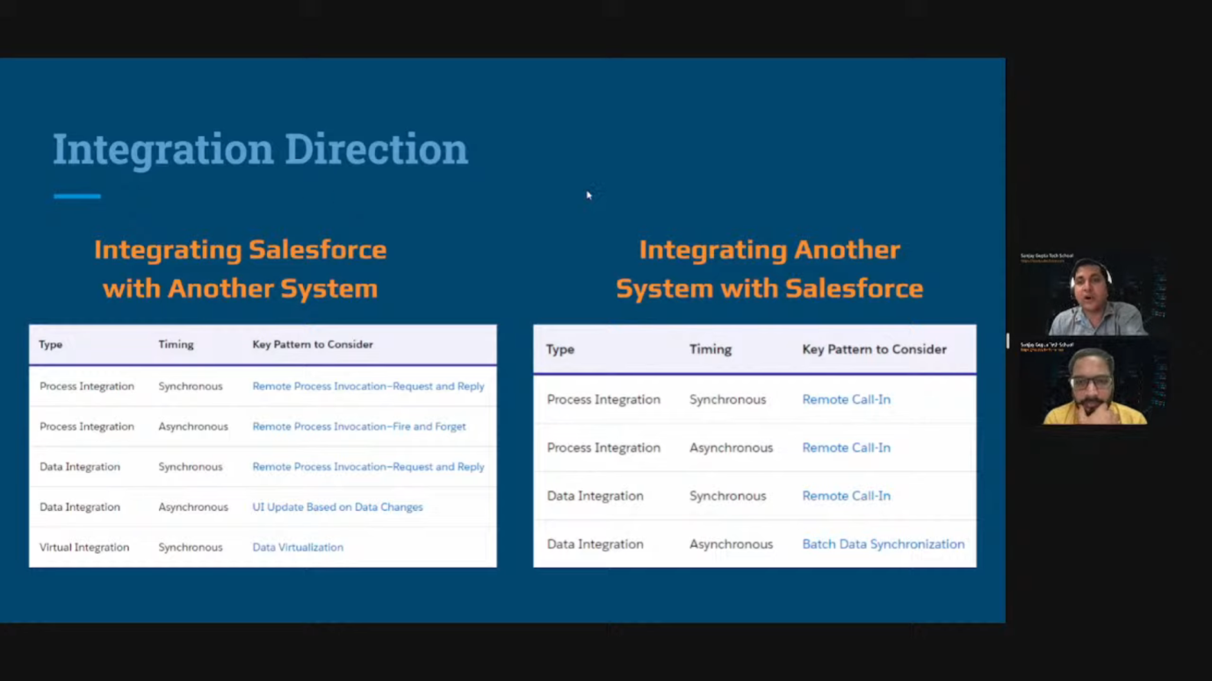

Day 61 | Part – 2: Salesforce Integration by Sanjay Gupta & Ankit Jain:

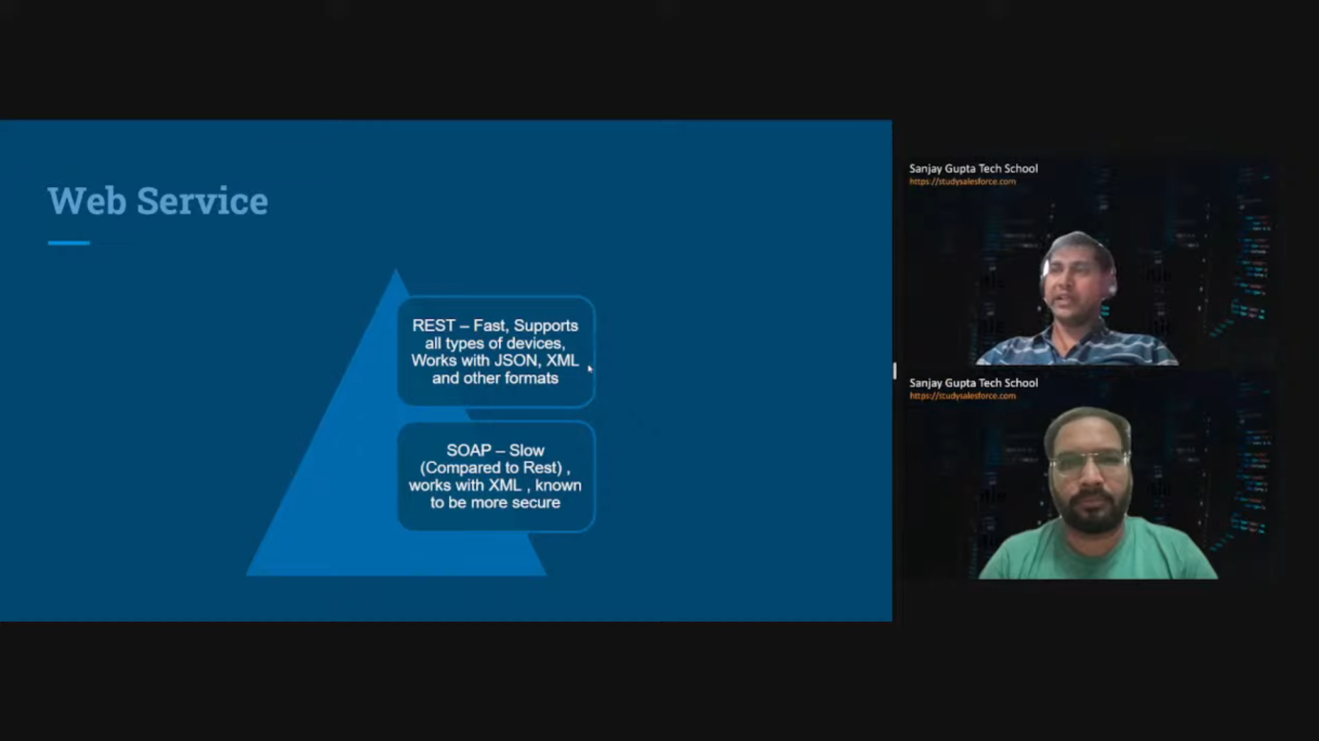

* REST is architecture design and SOAP is protocol.
* SOAP considered more secured then REST and if you are dealing with highly secured transaction then go for SOAP.

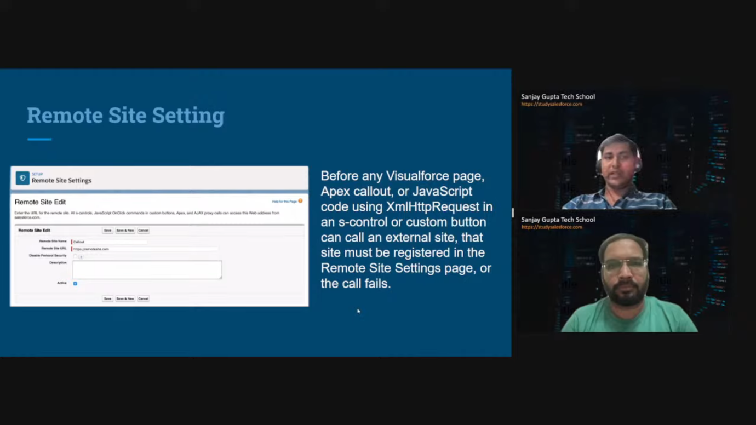

Note: when you do callout from lwc, aura or vf page then you have to configure the endpoints on Trusted URLs or Content Security Policy(CSP).

Note: Salesforce doesn’t recommend performing integration from JavaScript file from security reason. So, most of the architecture recommend to perform integration from apex only. It’s best practice to perform integration from apex. Not from JavaScript end.

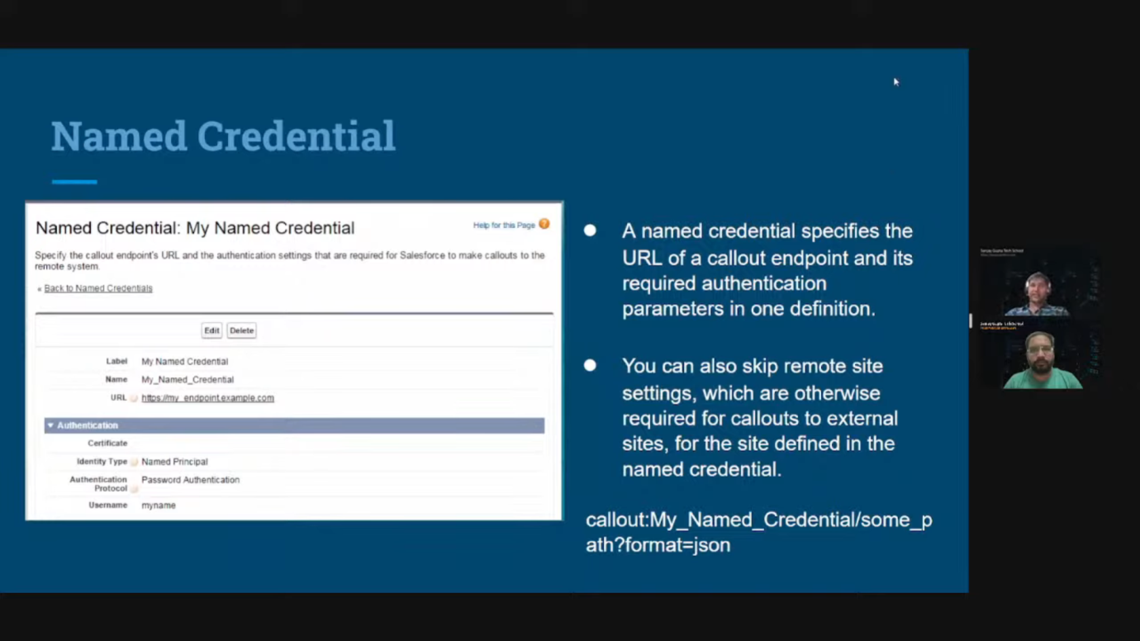

* Its advance form of remote site settings where you can specify authentication parameter as well. In remote site setting, you can only put endpoint only. Before introduction of named credential, when user needs to pass username and password then it’s create custom metadata or custom label or custom setting for it and wherever you put the password, it’s visible to admin. Its raise the security flag. To overcome this security, named credential is very helpful. When you put username and password inside named credential then password stored in encrypted form automatically.
* When you are using Named credentials then you don’t need to use remote site settings. But when you are using remote site setting then you need additional logic for passing authentication parameters.
* In latest release, Salesforce introduce the latest form of named credential.
* How to use Named Credential in apex class:
  + My_Named_Credential/some_path?format=json
* How to open named credential:
  + Setup->Named Credential -> New->New legacy
* Note: there is multiple authentication way through Named Credential. You can do.
* All the endpoint, response, which api to use & authentication type(there is multiple way of authentication like Oautn/userid_password/developer_api_key is provided by API provider.
* Instructor suggested this website for practice API integration: <https://numverify.com/documentation>
* Instructor suggested this website for practice API Integration: <https://spoonacular.com/food-api/docs>
* You can search public api on Google to find multiple available api to use and according to your interest. Integrate with your system.
* Note: Click on your avatar -> settings -> go on connections, now you can see the details whoever has access to your org data.

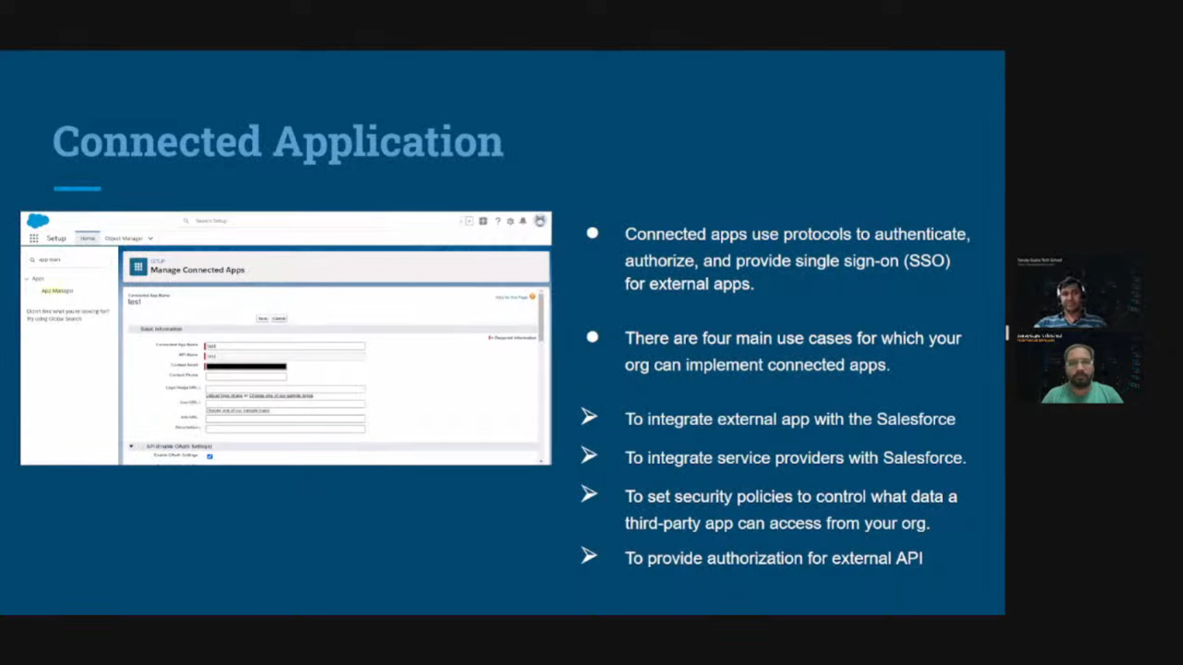

* When another system wants to access your Salesforce data, in this case we need to create connected app.
* After creation of connected app, another system needs consumer key and consumer secret key to access Salesforce data.
* When external system callout the Salesforce for data then it’s called inbound integration.
* When Salesforce callout the external system then it’s called outbound integration.

Day 62 | Part – 3 | Salesforce Integration by Sanjay Gupta & Ankit Jain:

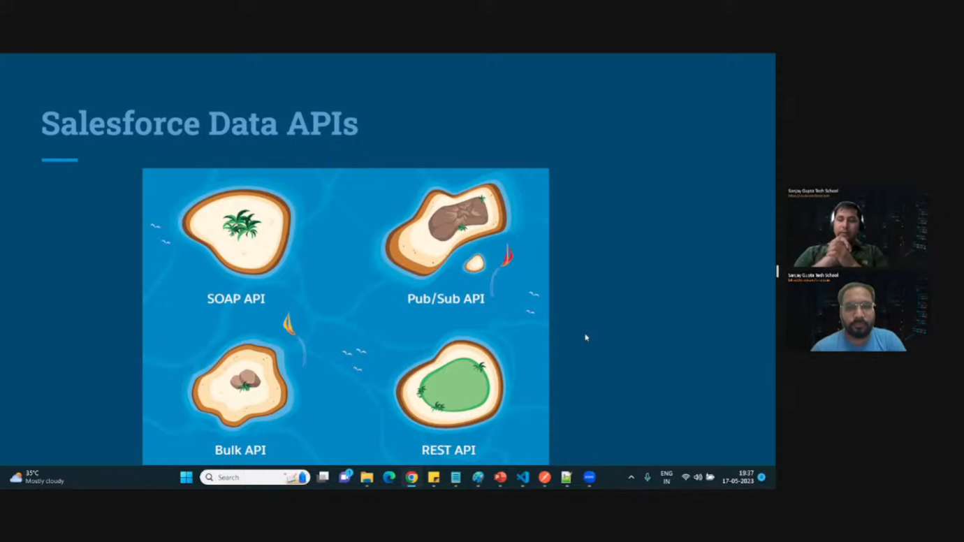

* There are more APIs whatever representing in above pics. It’s main APIs for system integration.

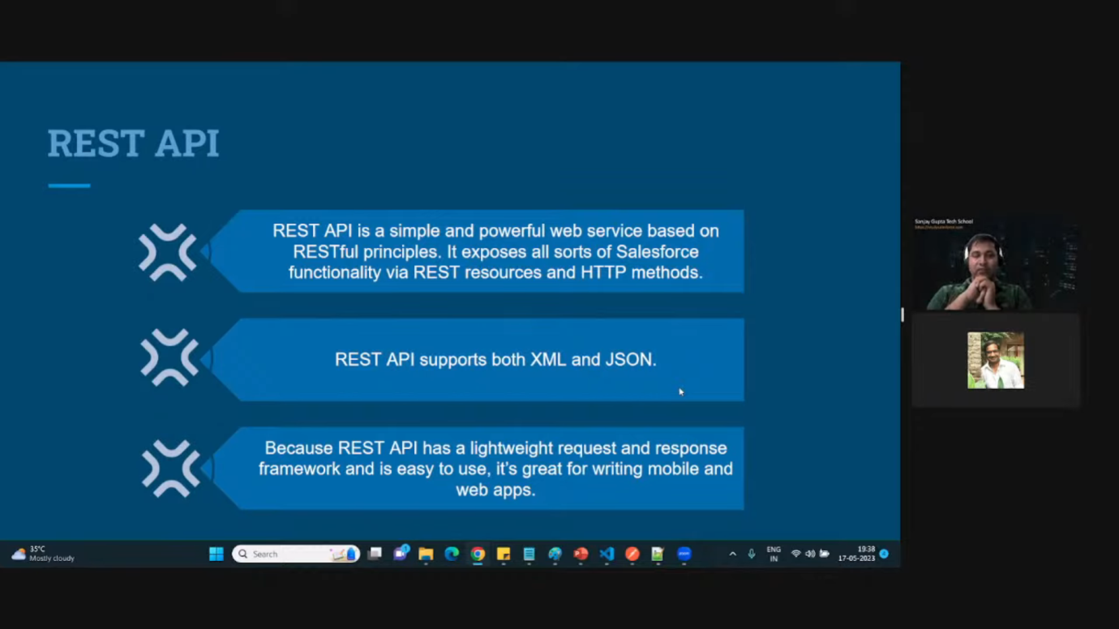

* REST API is stateless API means it doesn’t save the request on server. So, whenever we send request to server then we need to send required parameter.

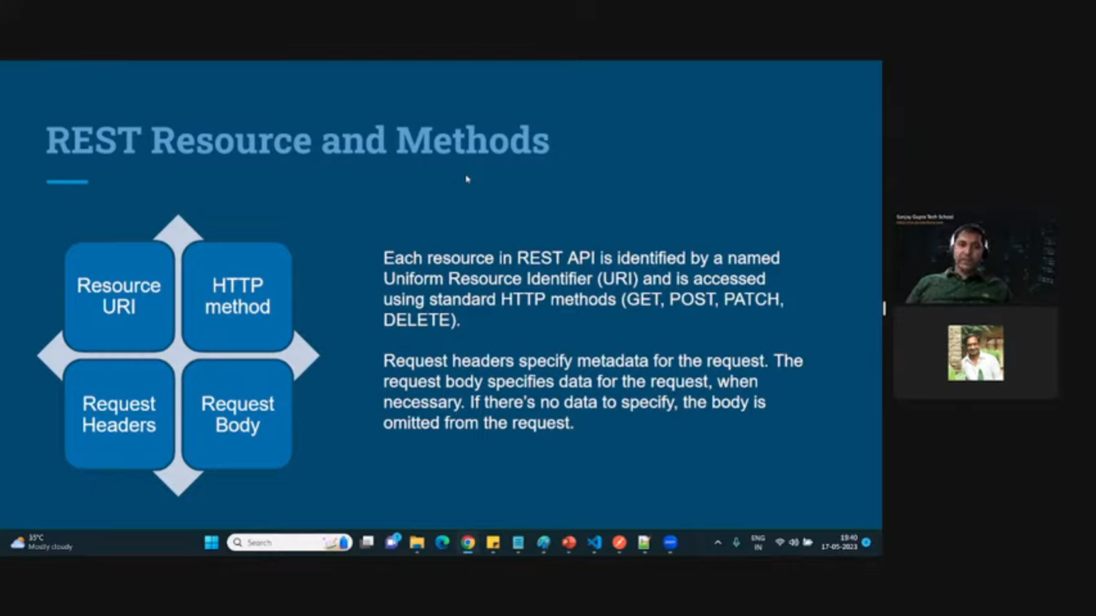

* Resource URI is the endpoint of API where we need to hit for getting the data.
* There are multiple HTTP method:
  + GET: when we want to get the data from third party system then we use “GET” method.
  + POST: when we want to insert the data to the third party system then we use “POST” method.
  + PATCH: when we want to update the data to the third party system.
  + Delete: when we want to delete the data from the third party system.
* In Request header, we specify the authentication details. We also specify the response data in request header. What type of format data, we want from external system.
* Request body is not mandatory parameter but whenever you use POST or PATCH then we have to specify the request body.
* Whenever we use GET and DELETE then Request body is not required.
* Note: whenever we don’t specify content-type in request header then JSON format is default.
* HTTP Response code status: <https://developer.mozilla.org/en-US/docs/Web/HTTP/Status>
* REST API Documentation: <https://developer.salesforce.com/docs/atlas.en-us.api_rest.meta/api_rest/intro_rest.htm>

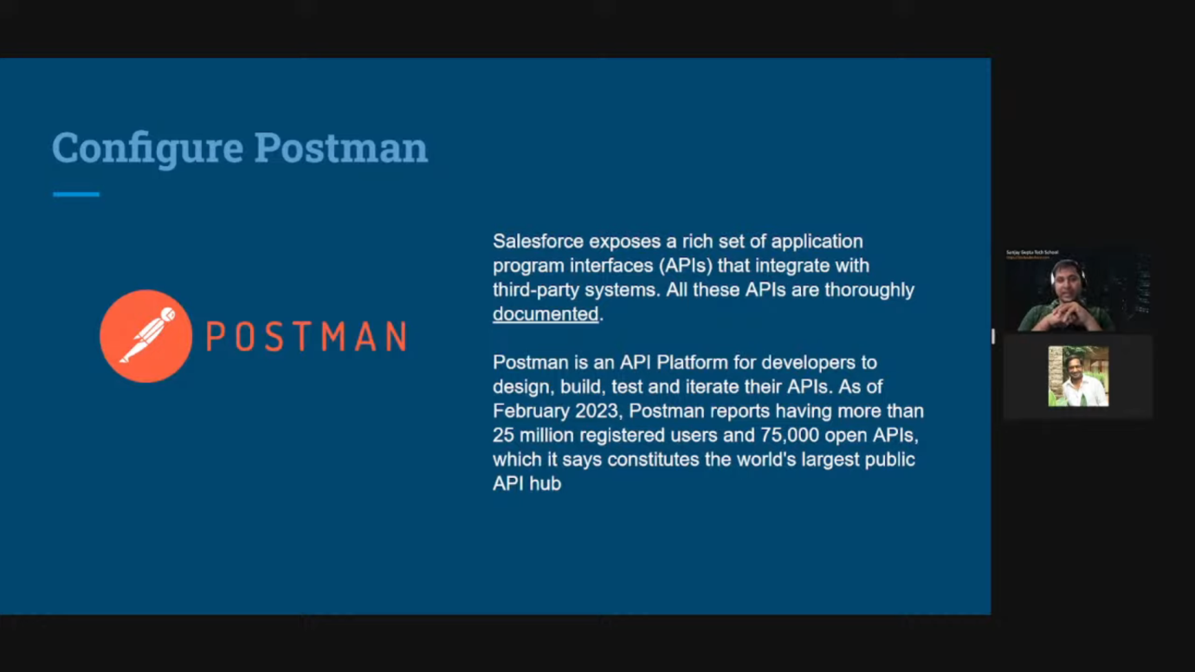

* How to connect POSTMAN with Salesforce Org:
  + Go on workspace menu -> Click on “Create Workplace”
  + Given the name(IntegrationDemo) and choose Personal in access setting
  + Click on Create button
* Your created workspace will be lunched and if you want to switch between different workspace. You can click on workspace for it.
* You can search the different APIs created by Salesforce
  + Go on search bar and search for Salesforce Developer
  + It will bring all the APIs list -> Go on Salesforce Platform APIs and click on three dots -> Create a Fork -> Give the label name and inserted into created workspace -> click on fork collection
* After above step, it will copied the Salesforce provided APIs into your workspace.
* Now, we need to connect the POSTMAN to Salesforce Org
* Click on label “Salesforce Platform APIs” and click on Authorization, you don’t need to change any setting like Type should be “OAuth 2.0” or Header Prefix as Bearer or leave other option as it is.
* After scrolling to the bottom, click on “Get New Access Token” and request will come to Salesforce org. so, click on allow- > need to allow pop-up and it will redirected to your POSTMAN app
* Copy the instance url from pop up screen of POSTMAN app
* Click use token button of pop up screen of POSTMAN app
* Now, need to go on variable section and scroll to _endpoint variable and paste in value section from copied instance url.
* Salesforce officials always suggest using postman rather than workbench.
* Access token has some expiry period, after certain period of time, you need to get new access token by following above process.
* Go on REST section from right side and click on Limit and it will auto populate with endpoint and click on send then in response body, you can see the data and if you want to study more about it then go on <https://developer.salesforce.com/docs/atlas.en-us.api_rest.meta/api_rest/intro_rest.htm> and search for limit api for more information.
* Whatever inside rest api section of postman, you can study from REST API developer doc. Just search for that keyword and you will get the detail doc for that.
* CURL is also a api testing tool like POSTMAN where organizations test APIs.
* You can multiple scenario for consuming Salesforce data from external system by seeing the API provided through Salesforce. Just explore these APIs.
* For understanding more about headers and other parameters, go for “Force_REST_API Cheatsheet” pdf which present in local Salesforce integration folder.

Day 63 | Part – 4 | Salesforce Integration by Sanjay Gupta & Ankit Jain:

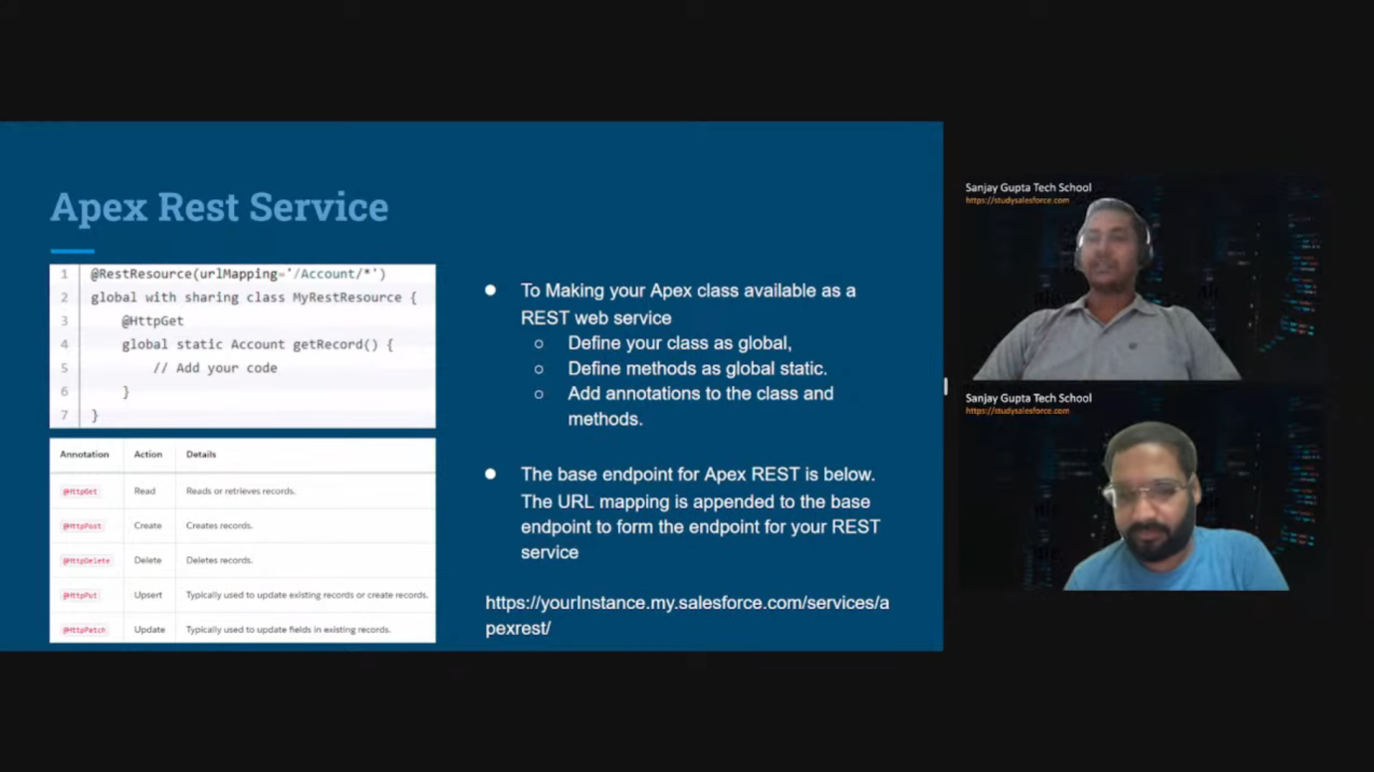

* There is a lot of standard API provided by Salesforce for fetching the record or manipulating metadata but, in some complex case/scenarios, we need to define our own APIs because, we can’t achieve that complex requirement through standard API.
* There is some consideration while we define our custom API class. See in above pictures.
* Base endpoint + defined Endpoint must be unique in your org.
* When multiple endpoint with the same name then platform will give unexpected behaviour from the platform.
* We have to define annotation for class level and method level as well.
* You can’t have more than one method with same annotation. When you do such thing then you will get compile time error.
* Go on REST Section-> click on Apex REST then you can just go in Path variable section and put the value in urlMapping. The value of urlMapping should be your mapping url after base url.

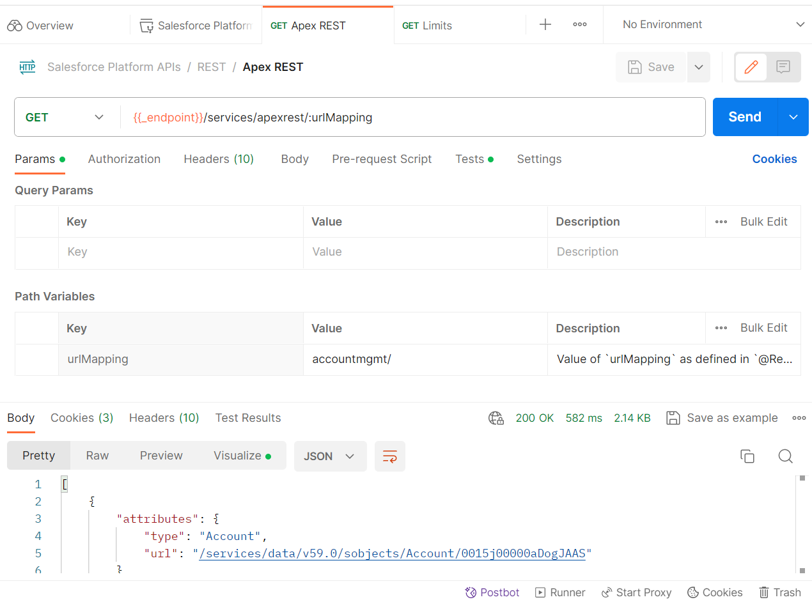

* Now, suppose get method is accepting the parameters then we can pass parameters in URL.
* For accessing the parameters passing through URL, we need to use apex context class provided by Salesforce. See below screenshot

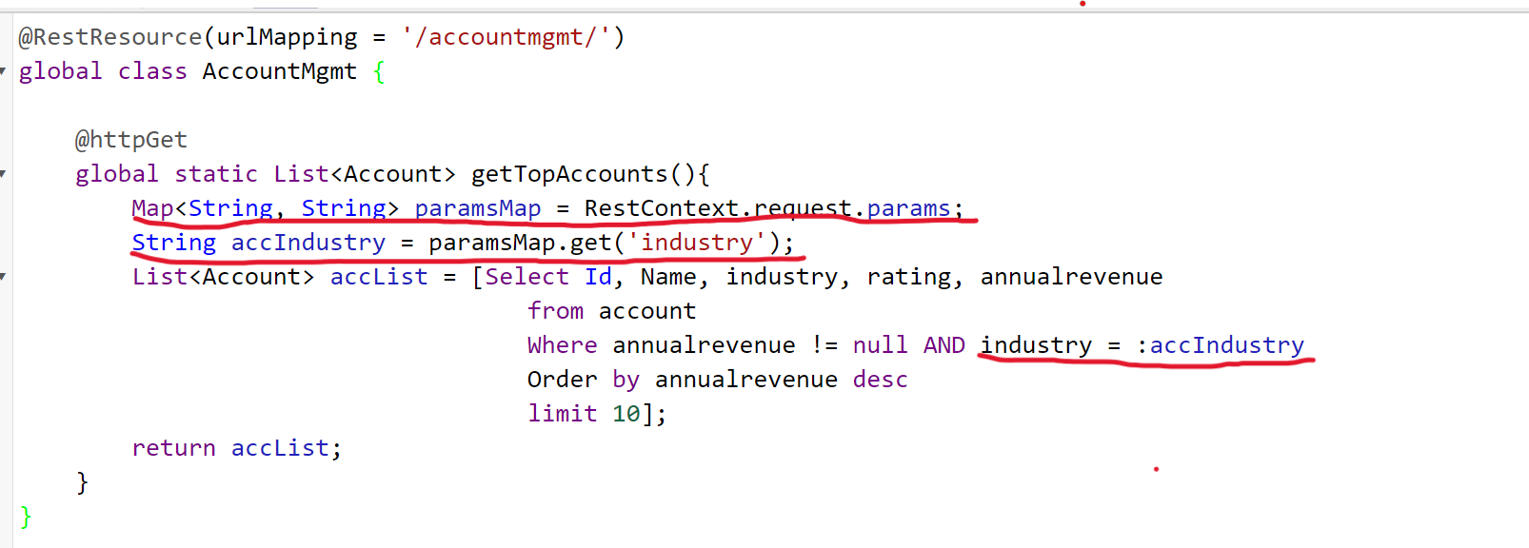

* Below screenshot will hit above endpoint and will fetch industry field record according to passed parameter. In below, screenshot you can see I have passed ‘Biotechnology’ as industry.

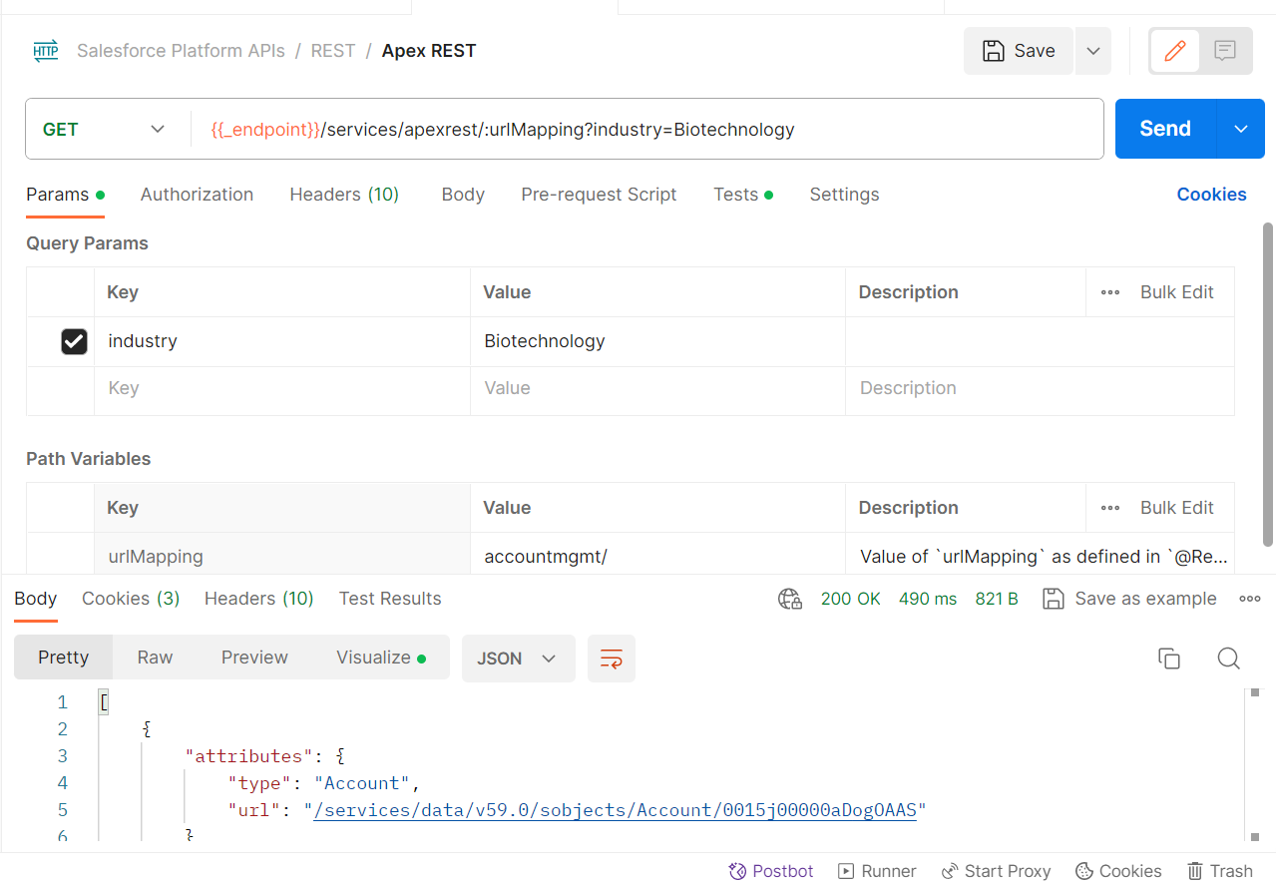

* Instructor taken another scenario where he is sending some complex data means suppose we need to send related contact of account and related case of account.

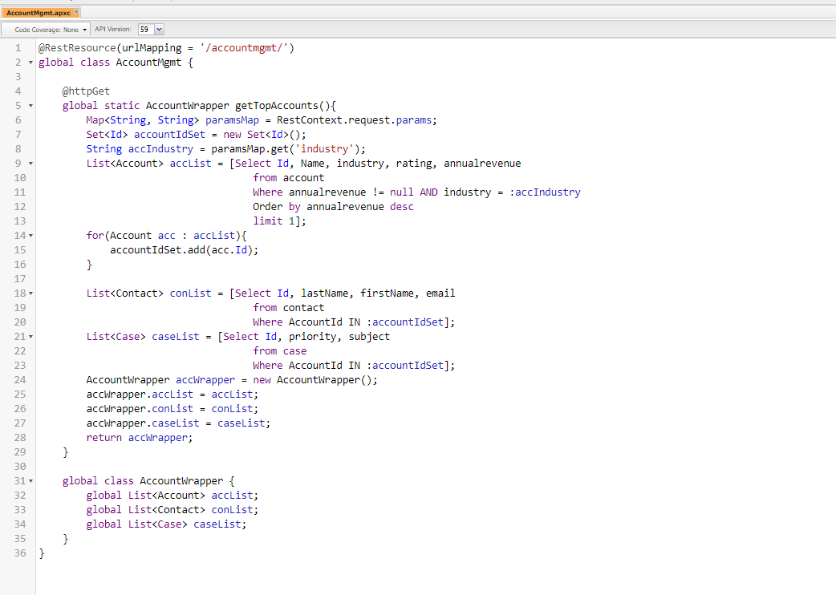

* This code is hitted by above same postman endpoint it will return account with related list of contact and list of cases.
* Instructor taken another scenario where he is demonstrating Post method and passing some value and it will create account in Salesforce:

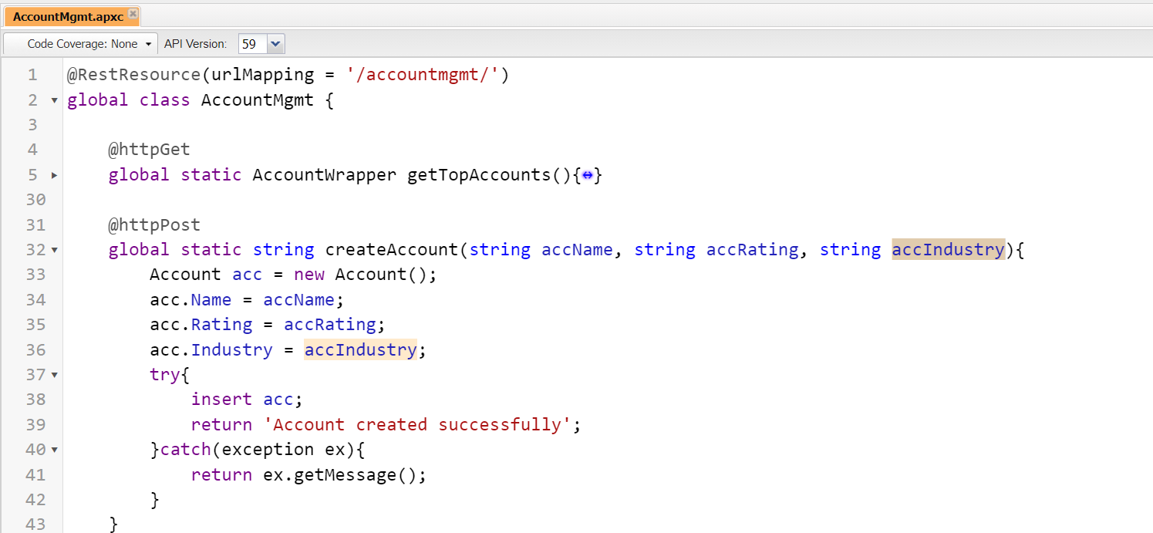

* Above post method hitted by following way through POSTMAN

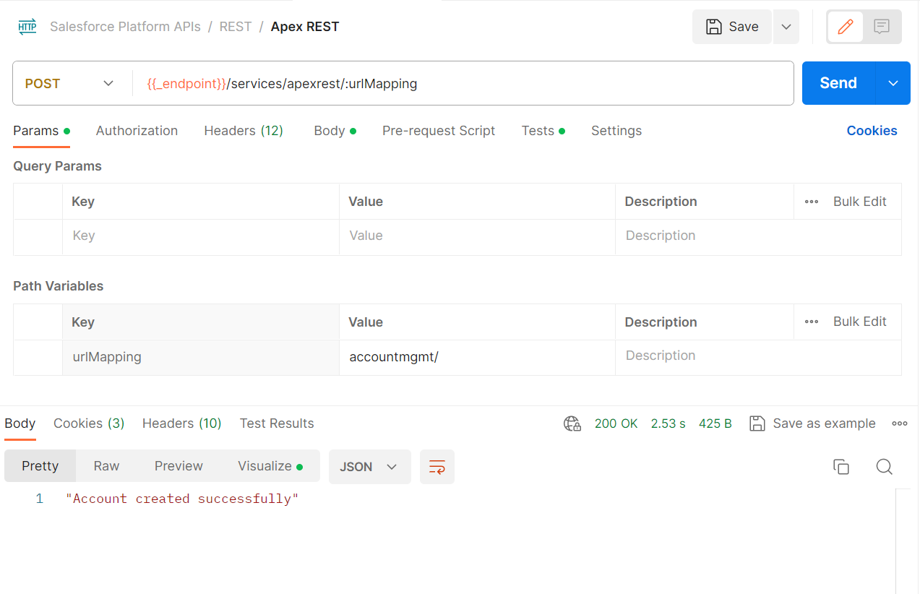

Note: parameter name of body of post callout in postman is same as parameter of above create account post method. See in below pic of body of post callout

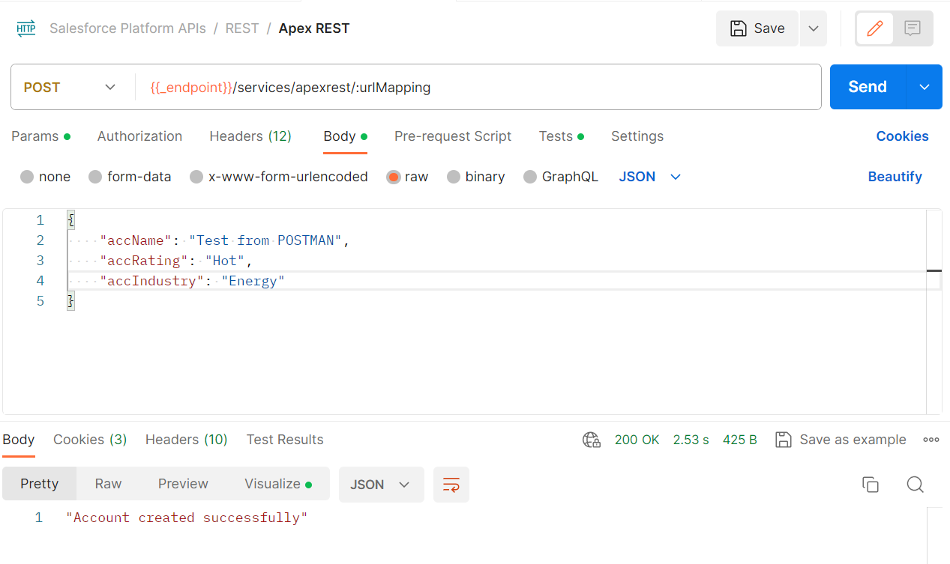

* Now, instructor taken another scenario where he is creating account and contact by passing the data once. See the below code for it.

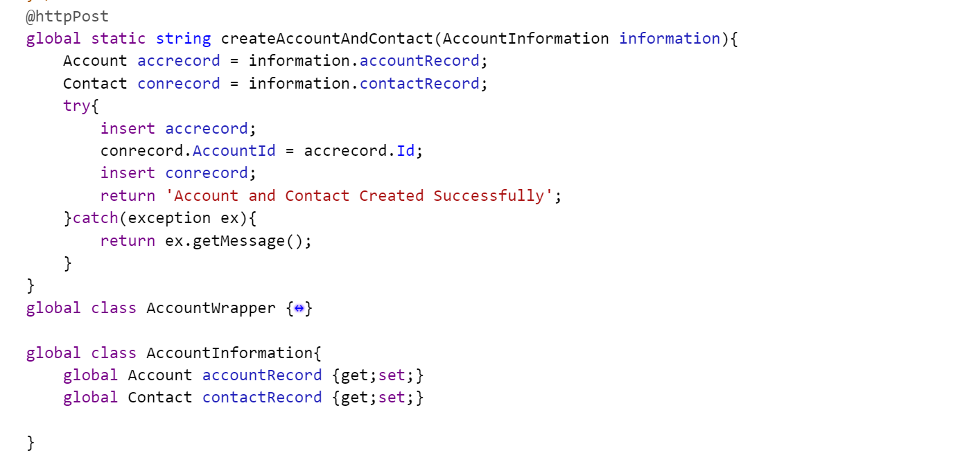

* Above code is hitted by following POSTMAN method and payload

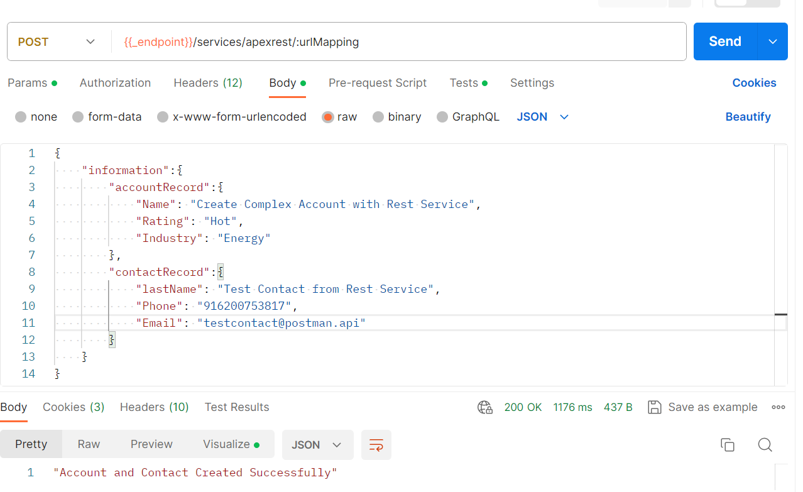

* Now, instructor took scenario to delete account by just passing account Id

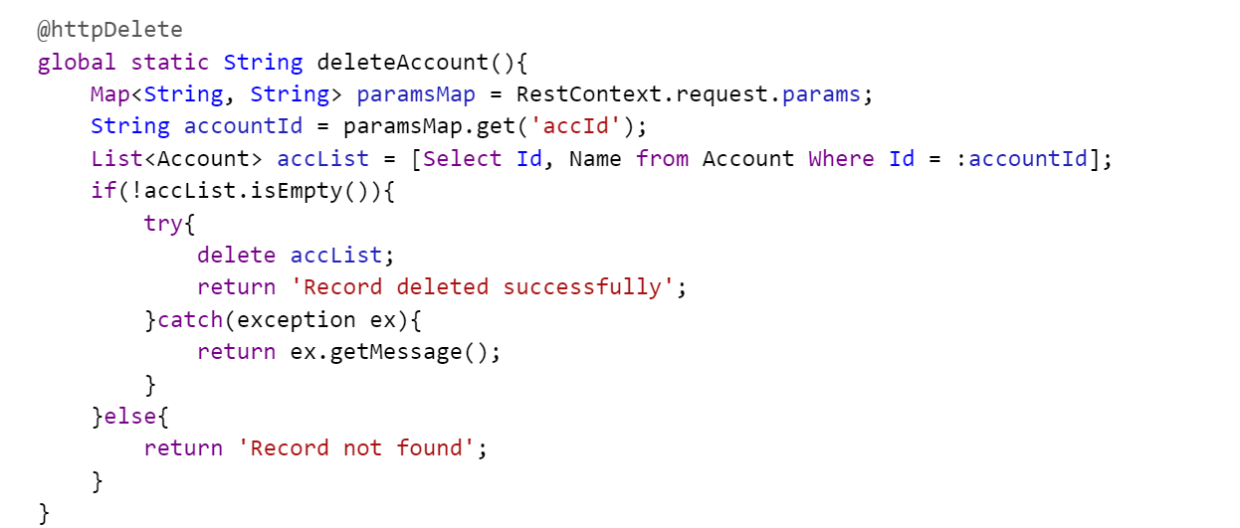

* Above code will hit by following postman setup:

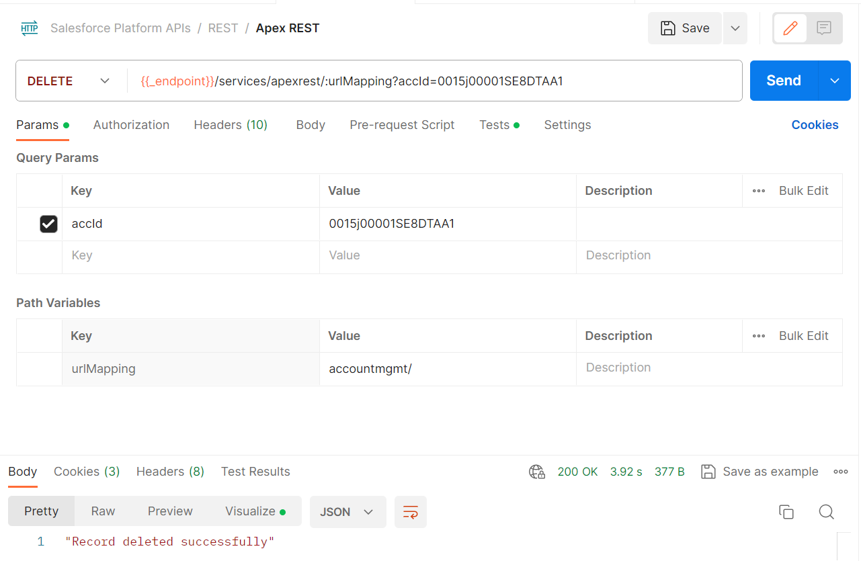

Day 64 | Part – 5 | Salesforce Integration by Sanjay Gupta & Ankit Jain:

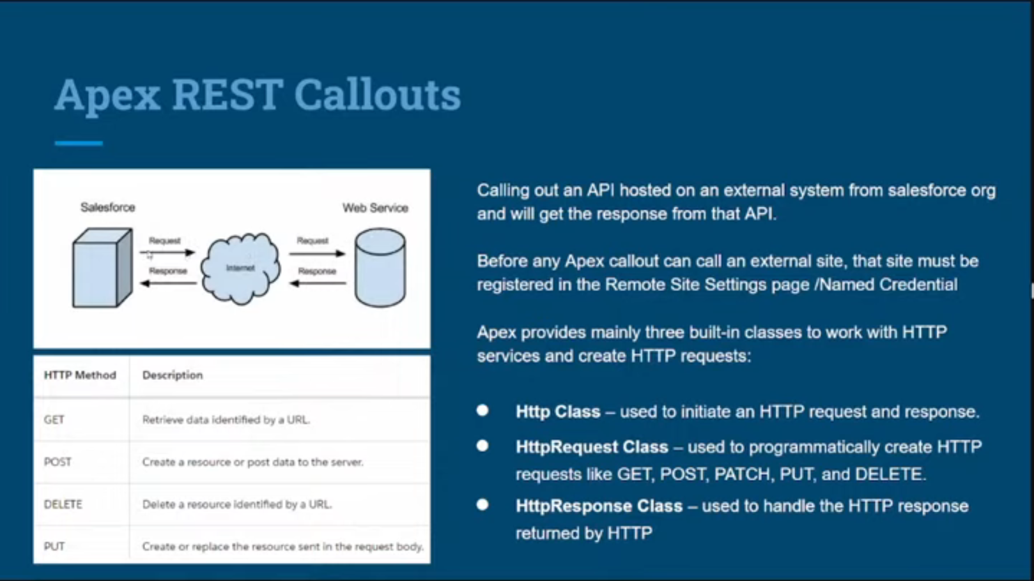

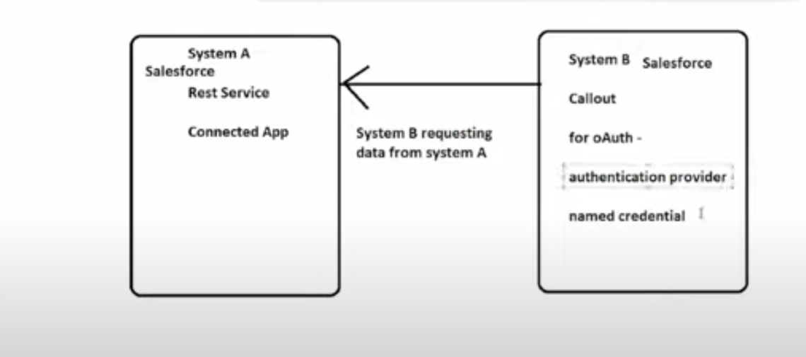

* In our scenario, system A is also a Salesforce system and system B is also a Salesforce system. Here, we will integrate both the system. In above picture, you can see that rest services are written in system A because, we consume system A data. In this case, we have to define connected app for accessing system A’s data.
* In this case, we have to integrating two system
  + [pankajkumardev@psl.com(source](mailto:pankajkumardev@psl.com(source) org – System A)
  + [pankajvitmca@pd1.com(system](mailto:pankajvitmca@pd1.com(system) B which consuming data from system A)
* In this case, I am creating connected app in system A. step for create connected App:
  + Go on Setup -> App Manager
  + Click on “New Connected App”
  + Give Connected App Name, API Name, Contact Email, Contact Phone, other options is optional
  + Enable OAuth Setting
  + Put Callback URL
  + Select from Available OAuth Scopes
    - Selected Full access(full), Selected Manage user data via APIs(api), selected Perform requests at any time(refresh_token, offline_access)
  + Now leave everything as it is and scroll down and click on save button.
* After creation of connected app then click on “Manage Consumer Details”
* You will get client key and client secret key or consumer key
* Go on system B which is consuming data(for this scenario, we have taken Salesforce as consumer system) so, go on setup-> search for Auth. Provider -> Click on New
  + Give the provider name(there are multiple type of provider and everyone has their own type of authentication providing system, so in this case we will choose Salesforce
  + Then put the name anything
  + Copy consumer key from system A and paste in consumer key section
  + Copy Consumer Secret from system A and paste in consumer secret section
  + Leave authorize endpoint url and token endpoint url as it is.
  + Default scope is mandatory where you need to fill with space between two scope, in our case we choose “refresh_token”, “full” from select Oauth scope of system A.
  + Now click on save
* Copy Callback URL from system B which generated after Auth. Provider and paste inside Callback URL section of created connected app of system A.
* Need to define Named credential inside system B which is consuming the data
  + Setup -> Named Credential
  + Click on New dropdown -> click on new legacy
  + Give the label(I have given SFDCB)
  + Give the Name(given SFDCB)
  + Now, need to define the URL
    - Copy the base URL from system A url
    - And put inside URL section of Named Credential
  + Choose Identity type as “Named Principal”
  + Authentication provider as OAuth 2.0
  + Choose Authentication Provider as created Auth. provider name – “Salesforce Connected App”
  + Click on save and it will redirected to login screen. Need to provide System A credential and allow all the step. Now, you can see Authentication status as Authenticated as [pankajkumardev@psl.com](mailto:pankajkumardev@psl.com)
* Now, I am authenticated by System A. now, fetching the account records from system A
* <https://json2apex.herokuapp.com/>
* Above is the best resource for convert json into apex code.

Code Inside System B for fetching data from System A

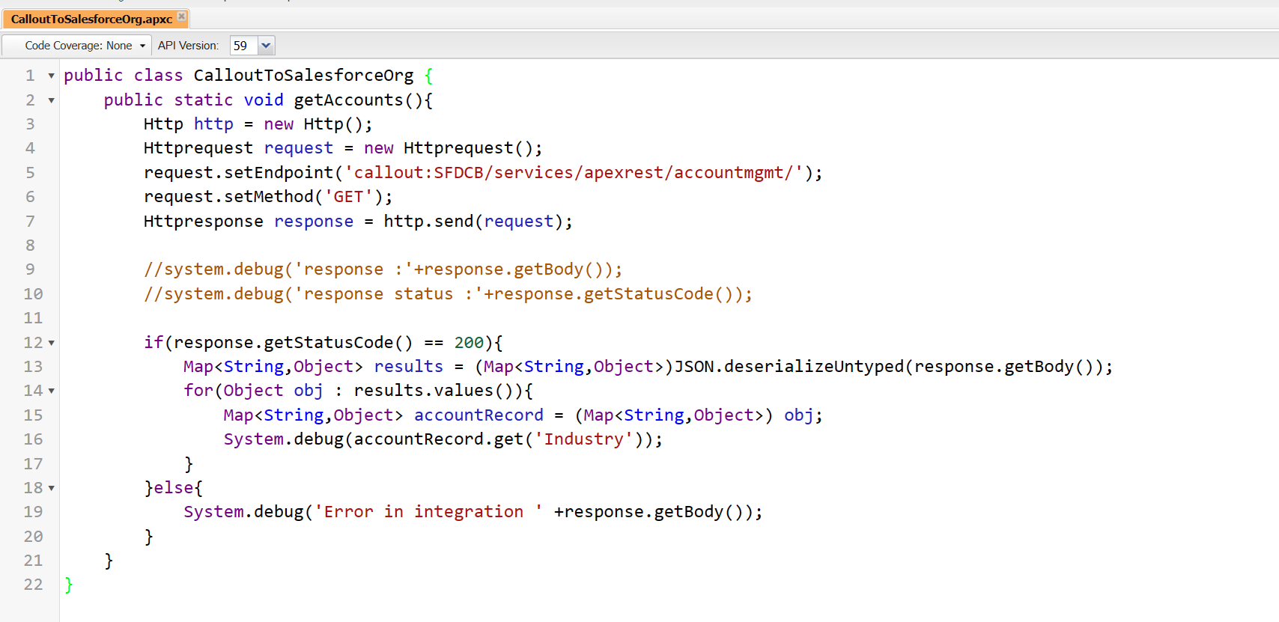

Code inside System A for giving data outside of Salesforce when someone hit on particular endpoint:

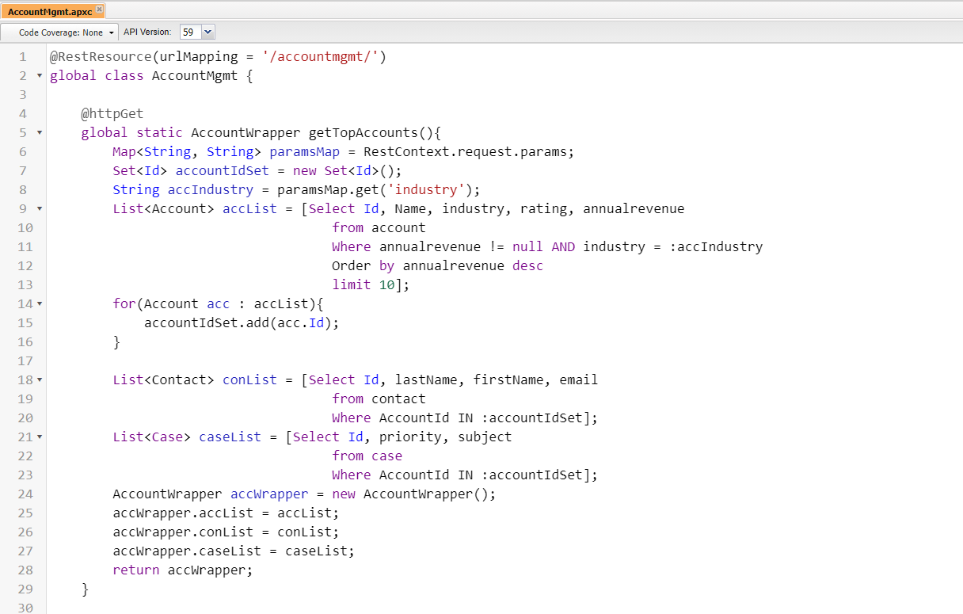

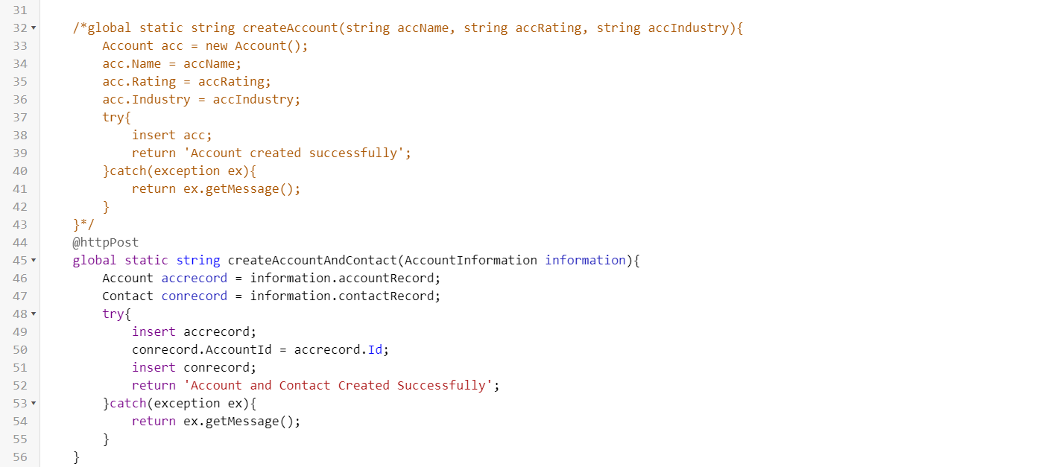

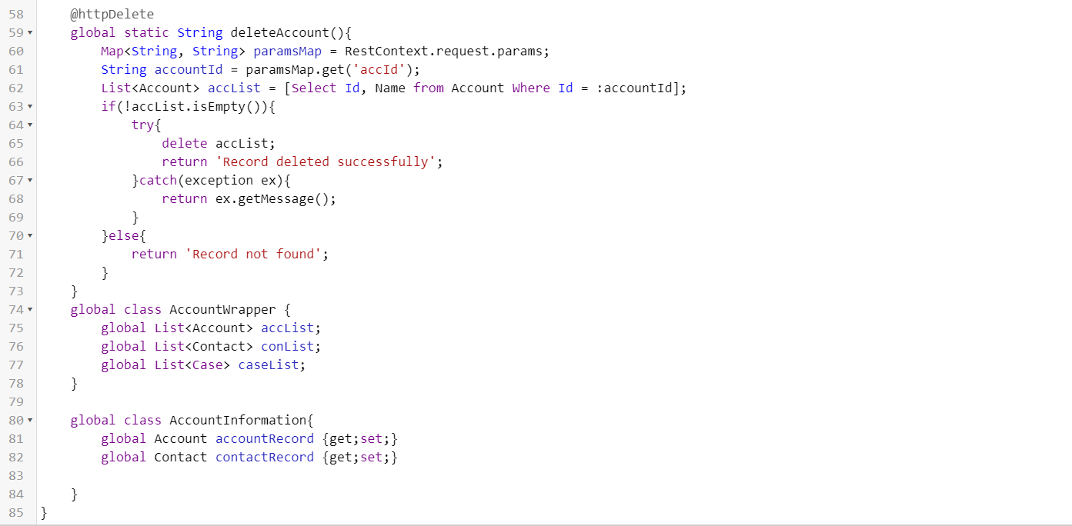

Day 65 | Part - 6 | Salesforce Integration by Sanjay Gupta & Ankit Jain:

* In this scenario, he is integrating Salesforce and LinkedIn. Will post on linkedIn via Salesforce.

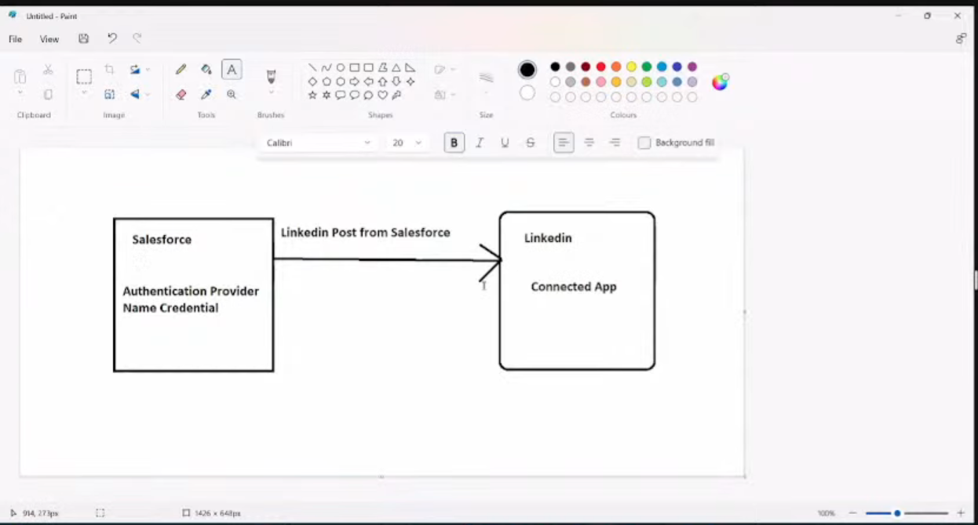

* Go on linkedIn developer, linkedIn is also provide kind of connected app to access their data via so, need to create connected app inside linkedIn developer.
* Sign-in inside LinkedIn developer, create a connected app
  + Give app name
  + Need to specify the company page, so in this case, I have created a new company page “The Coding Tunnel”.
  + In auth section, you can find client ID and client secret.
  + Need to define the scope, so go on product section and get access of Share on LinkedIn & Sign in with LinkedIn.
  + Now, go auth section and you will see oAuth 2.0 scope
* You need to verify created LinkedIn page as well.
* Now, need to go on Salesforce and need to do some configuration in Salesforce org whose will consume the data of LinkedIn.
  + Go on setup-> Auth. Providers
  + Click on new
  + Choose provider type as linkedIn
  + Choose Name(given linkedIn)
  + Fill consumer key and consume secret from linkedIn created application.
  + I need to fill authorize endpoint URL & token endpoint URL and I will get the URL on API doc - <https://learn.microsoft.com/en-us/linkedin/shared/authentication/postman-getting-started>
  + Go on authentication section of linkedIn API doc.
  + Click on save now.
* After clicking on save, we get callback URL on Auth. Providers page of salesforce, copy the callback URL and go on create app section of LinkedIn, paste the URL inside “Authorized redirect URLs for your app”.
* Now, need to configure Named credential inside Salesforce org.